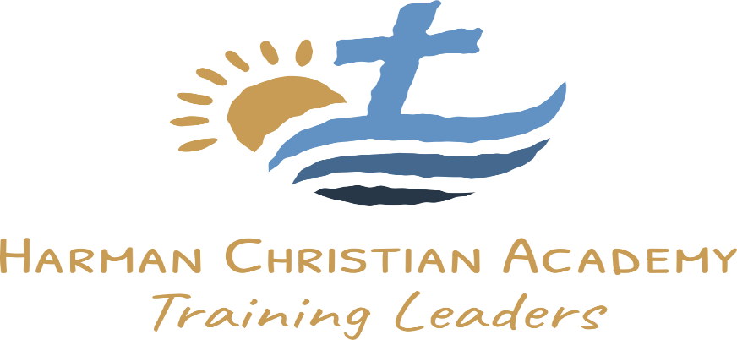

Tuition & Financial Aid
Tuition for the 2024-2025 School Year

- Preschool: 3 day ½: $173, 3 day full: $340, 2 day half: $115, 2 day full: $230
- PreK $3800
- K-1st - $3500
- Application fee is $50 (Non-refundable)
- Registration Fee/Re-enrollment deposit - $380 per student (Non-refundable)
- PreK & K book fee $165 for year, 1st book fee $185
- We do monthly payment draws or if you pay all at once receive 2% discount.

Payment plans:

- One time 2% discount
- 12-month July-June
- 10-month September-May

-We do monthly ACA checking account draws, or cash due by 5th day of each month.

Financial Aid and Discounts:

-We offer multi-student discounts to all classes.
-2 or more students $500 discount per student

Kindergarten and up
-We offer Scholarships from renewanation.
-Harman Memorial Baptist Church offers partial scholarships.
-NLBA partial scholarships available

